**Future of Food: EIT Food engages local community**

**News 11/11/2019**

[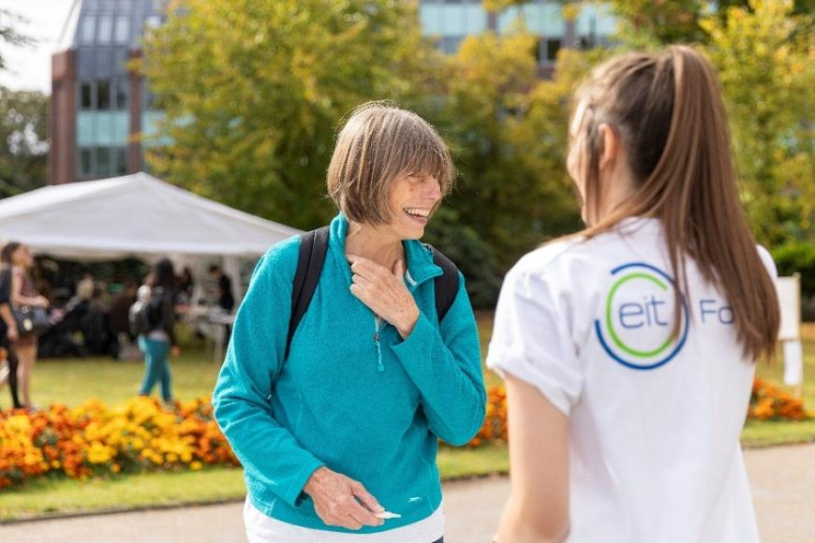](https://eit.europa.eu/sites/default/files/eit_food_engages.jpg)

[**EIT Food**](https://www.eitfood.eu/)**participated in the Reading Town Meal event in the UK in September 2019, where the local community gathered together to celebrate healthy and sustainable food.**

At the [event](http://www.readingtownmeal.org.uk/), food was donated by local growers and allotment holders and cooked by students from the local college. These tasty and healthy meals were a celebration of local and sustainable food served for free and enjoyed alongside family entertainment, including live music from local bands. EIT Food had a marquee at this event and engaged with the community through fun and educational activities.

**Engaging with families on the Future of Food**

EIT Food offered fun and educational games including virtual reality experiences demonstrated by Hordur Kristinsson, the Chief Science & Innovation Officer, and Holly Kristinsson, the Consultant for Research & Innovation from [MATIS](https://www.eitfood.eu/partners/partner/matis). Virtual reality headsets were particularly popular with children who could experience the future of food by exploring the kitchen of the future and tomato farms in Iceland, all while being in their local park.

*Virtual Reality is an amazing tool to engage and bring a personal and community connection to food. At the Reading Town Meal people were surprised and amazed by how they can feel as though they are in the food system and become immersed in food tech!*

*Holly Kristinsson, MATIS*

Dr Natalie Masento from the [University of Reading](https://www.eitfood.eu/partners/partner/university-of-reading) put the EIT Food [‘Games of Food’](https://www.eitfood.eu/public-engagement/projects/games-of-food/)project into practice, by running ‘Escape Games’ for families. This project is increasing public awareness around balanced nutrition and a healthy lifestyle through the use of these newly developed games. During the event, teams escaped a Zombie Attack by solving food-related puzzles while competing to complete the game in the fastest time. The game demonstrated how families can learn about food together to increase their overall knowledge of smart food choices.

*Gamification is the best way to teach in my opinion.*

*Games of Food participant*

Other activities included a food waste treasure hunt where families searched for images of commonly wasted food products such as bread and potatoes to raise awareness of the food waste crisis. Families who completed the treasure hunt won prizes, including Food Waste Recipes to encourage repurposing leftovers rather than throwing them away.

EIT Food also tested the local community’s knowledge on seasonal fruit and vegetables to encourage consumers to grow their own food to enjoy throughout the year.

To help people understand more about how much sugar is added to common foods, four popular food and beverage products were displayed outside the EIT Food tent including: Cola drink, Low-Fat yoghurt, Baked Beans and Tomato Sauce. When asked: ‘Which contains the highest amount of added sugar per 100 grams?’, people could simply place a cork in the jar behind their choice. The most common answer was Coca drink. *Do you agree? Let EIT Food know what you think*[*here*](https://www.facebook.com/EITFood.eu/photos/a.1898455643732275/2485645285013305/?type=3&theater)*.*

**Promoting our free online food courses**

EIT Food held a public talk on one of our free online courses helping people discover more about the food they eat. The talk was led by Andrew Ainslie, a Social Anthropologist from the International Development Group at the University of Reading. Andrew discussed the free online course [‘Engaging with Food Controversies in the Food System’.](https://www.futurelearn.com/courses/engaging-with-controversies-in-the-food-system) The three-week course is available on [FutureLearn](https://www.futurelearn.com/partners/food) and enables learners to assess the reliability of different sources of food information and understand more about the most common food controversies - alternative proteins, palm oil, and probiotics.

**Learning about the value of food**

The outcome of the event was to bring the Reading local community together through food. EIT Food engaged with consumers on the importance of reconnecting with food and valuing the journey food makes from ‘farm to fork’.

*It’s good for the kids to learn about the food they eat.*

*Games of Food participant*

According to Education Programme Manager Vivien Bodereau, 'Food bonds people together and encourages discussion” and that was the aim of the local community event. After engaging with the public, it was clear that people have different opinions on food, whether it is choosing to buy local products or adopting a plant-based diet for the benefit of the planet. Consumer opinions are vital in shaping the future of food, as their consumption behaviours influence the actions of the food system.  EIT Food is encouraging everyone to get involved to help us improve food together.